Reactive Programming Document
- Reactor is a library which provides the impl of the async non blocking stream processing.
- Reactor Publisher is an interface and provides 2 impls: Mono and Flux.

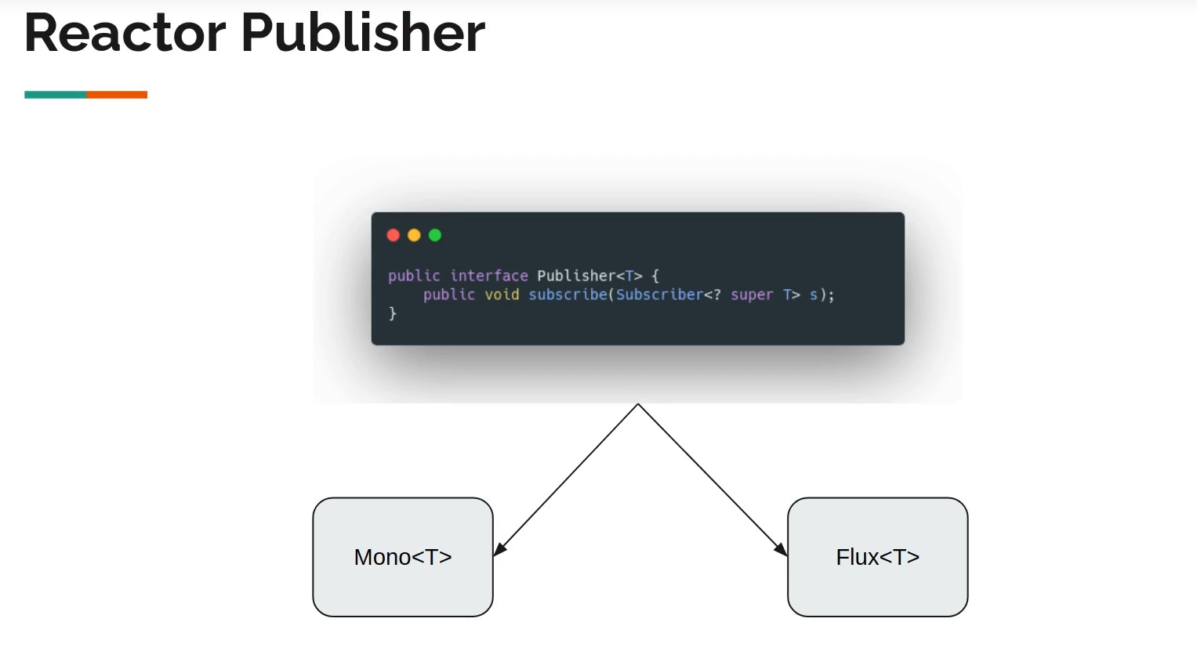
- A Mono publisher can emit 0/1 records, it can also emit just onComplete and onError if it wants to tell that there is no data or an error.

